**[F29DC 2024 Lab 1 - Connectivity, VPCs, Subnets, VLANs](https://canvas.hw.ac.uk/courses/28951/files/3694381?wrap=1" \o "F29DC 2024 Lab 1 - Connectivity, VPCs, Subnets, VLANs.pdf" \t "_blank)  
- Shyam Sundar Velmurugan  
- H00418621**{ Part 3 }   
VLANs  
  
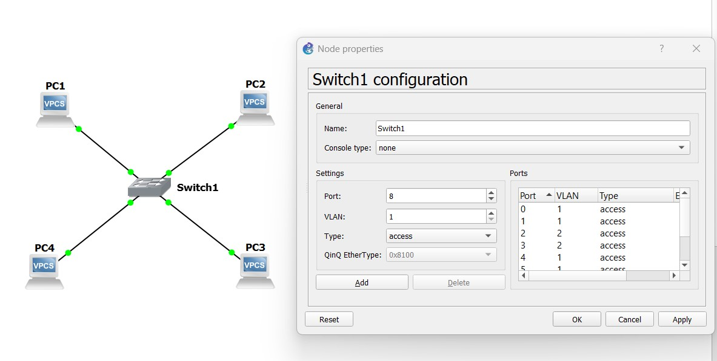  
Image 3.1: Configuring the VLAN’s by changing the PC3 and PC4 from 1 - 2  
  
  
  
  
  
  
  
  
  
  
  
  
  
  
  
  
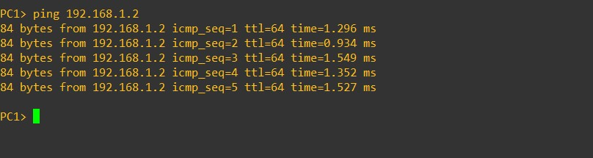  
Image 3.2: Checking if we can ping PC2 from PC1 after changes.  
  
  
  
  
  
  
  
  
  
  
  
  
  
  
  
  
  
  
  
  
 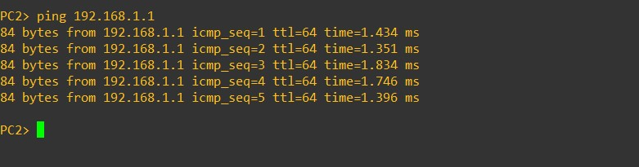  
Image 3.3: Checking if we can ping PC1 from PC2 after changes.  
  
  
  
  
  
  
  
  
  
  
  
  
  
  
  
  
  
  
  
  
  
  
  
  
  
  
  
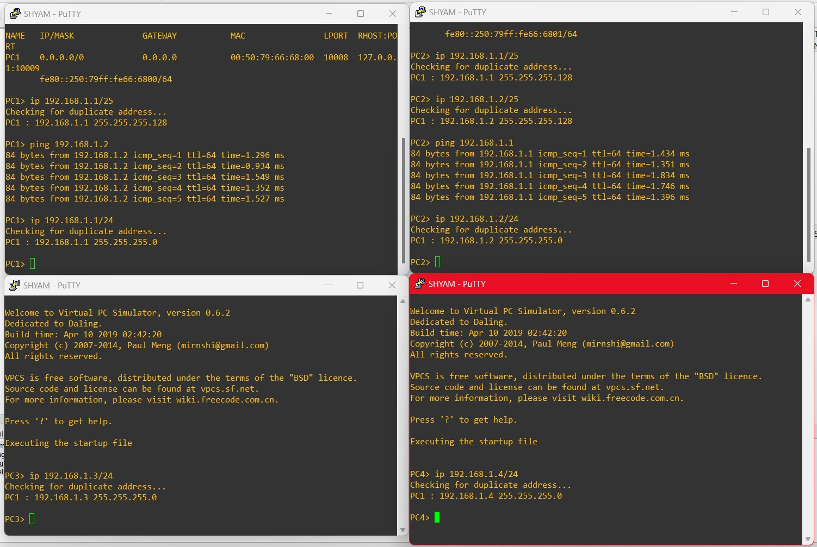  
Image 3.4: Configuring all the PCs under same network in the IP address ranging from 192.168.1.1-4/24.  
  
So the new IP’s will be:  
  
PC1 – 192.168.1.1/24  
PC2 – 192.168.1.2/24  
PC3 – 192.168.1.3/24  
PC4 – 192.168.1.4/24  
  
  
  
  
  
  
  
  
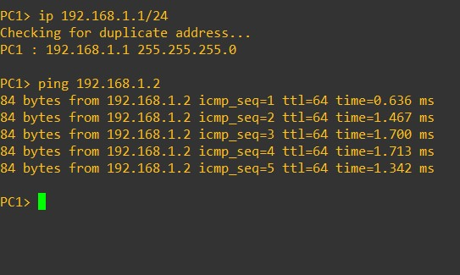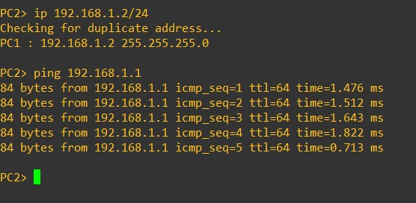  
Image 3.5: Trying to Ping PC1 from PC2.  
= It gets pinged both ways.   
  
  
  
  
  
  
  
  
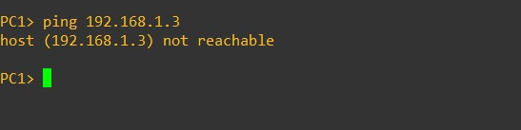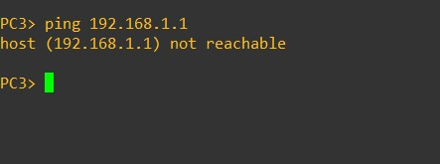  
Image 3.6: Trying to Ping PC3 from PC1.  
= The host is not reachable and therefore cannot be pinged in both ways.  
  
  
  
  
  
  
  
  
  
  
  
  
  
  
  
  
  
  
  
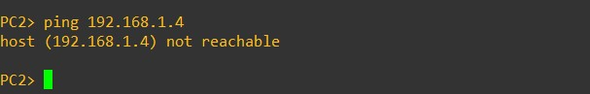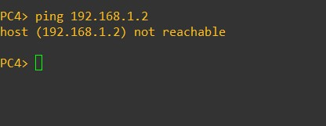  
Image 3.7: Trying to ping PC4 from PC2.

= The host is not reachable and therefore cannot be pinged in both ways.  
  
  
  
  
  
  
  
  
  
  
  
  
  
  
  
  
  
  
  
  
  
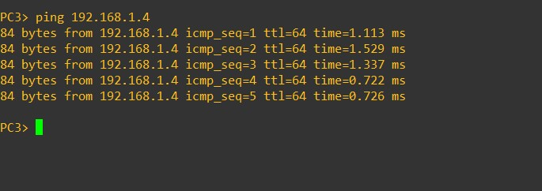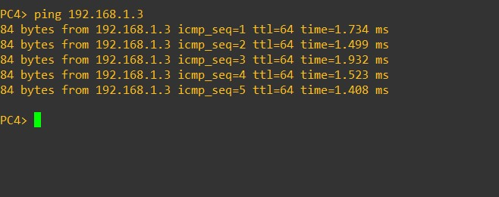  
Image 3.8: Trying to ping PC4 from PC3.  
= It gets pinged both ways.  
  
Conclusion: The pinging between PC4 - PC3 and PC1 - PC2 were successful while PC3 - PC1 and PC2 - PC4 werent successful because of different VLAN connections. The VLAN connection for PC1 and PC2 is 1 , while PC3 and PC4 is 2.